**3.1 Ultrasound Waves**

Ultrasound waves are a type of mechanical waves. This means that it requires a medium (such as air, water, or solids) to propagate, unlike electromagnetic waves which can travel through a vacuum. As ultrasound waves are longitudinal waves, the particles move parallel to the wave direction, creating areas of compression and rarefaction.

The amplitude of a sound wave represents its strength or intensity, measured as the difference between the peak pressure and the average pressure in the medium. A larger amplitude corresponds to a louder sound, while a smaller amplitude indicates a quieter sound. In medical ultrasound, the amplitude is measured in decibels (dB) and can be adjusted by the sonographer through the transmit power of the ultrasound machine.

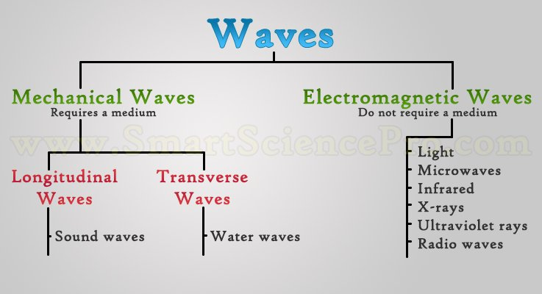

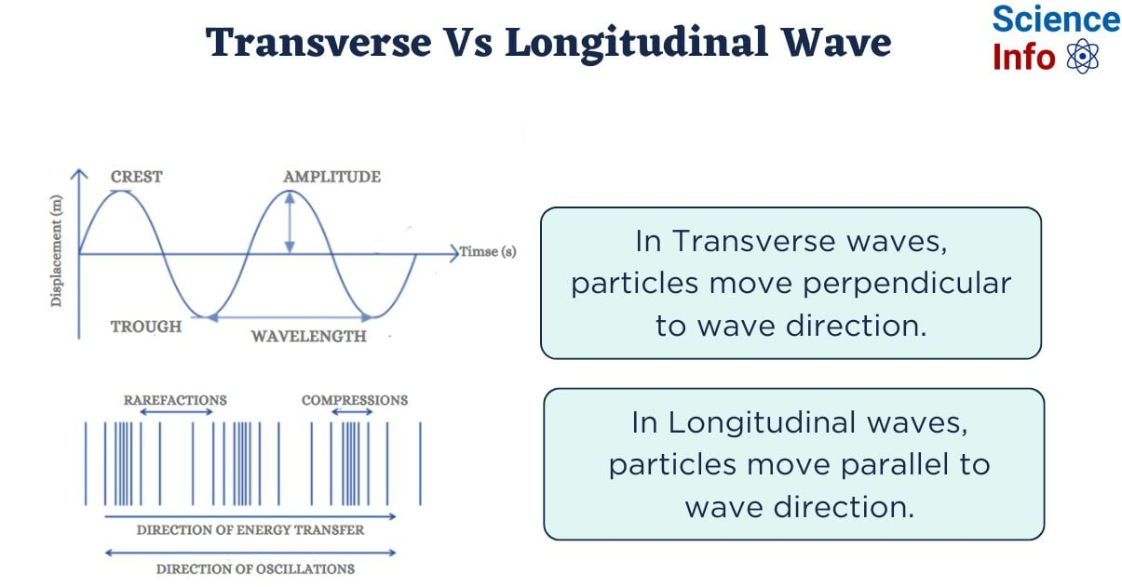

**3.2 Ultrasound Waves Formula**

The formula that relates the velocity, frequency, and wavelength of ultrasound waves is:



**Components of the Formula**

**Velocity**: This is the speed at which ultrasound waves travel through a medium. In human soft tissue, the average speed of ultrasound waves is 1540 meters per second (m/s). This value is used by ultrasound machines to calculate the depth of structures based on the time it takes for the sound waves to travel and return.

**Frequency**: This refers to the number of wave cycles (oscillations) that occur per second and is measured in Hertz (Hz). For example, a wave with 100 cycles per second has a frequency of 100 Hz. For higher frequencies, we use kilohertz (kHz) (1,000 Hz) or megahertz (MHz) (1,000,000 Hz). The frequency of ultrasound waves is inversely related to their wavelength. This means that as the frequency increases, the wavelength decreases, and vice versa.

* Audible sound lies between 20 Hz to 20 kHz.
* Ultrasound refers to sound waves with frequencies above 20 kHz.
* For echocardiography, the typical frequency range is 1.5 MHz to 7 MHz.
* Higher frequencies provide better image resolution but have poorer depth of field due to attenuation.
* Paediatric echo uses higher frequencies than adult echo only a shallow depth of field is required.

**Wavelength**: This is the distance between two successive peaks or troughs of a sound wave. It is typically measured in meters (m) or millimeters (mm). A shorter wavelength results in better resolution but also leads to poorer depth of field, meaning it can only visualize structures close to the surface.

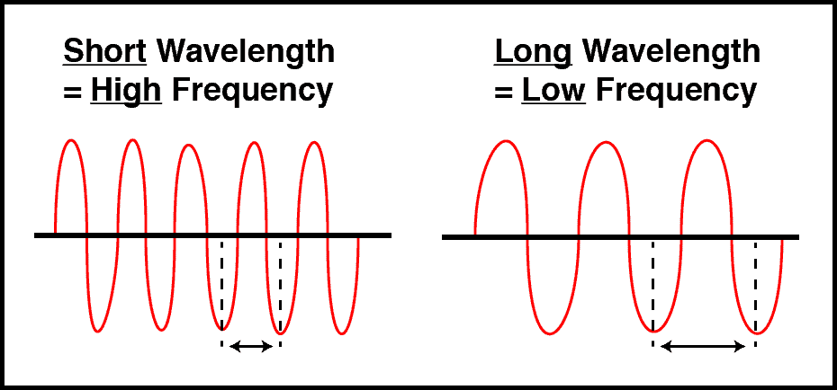

**3.3 Ultrasound Transducers**

**Key Components of a Transducer**

* **Acoustic Lens:** Aids in focusing ultrasound beam
* **Matching Layer:** Enhances impedance matching between the piezoelectric elements and the patient’s body.
* **Piezoelectric Elements:** Generate and detect ultrasound waves.
* **Backing Layer:** High impedance layer that absorbs ultrasound waves and dampens reverberation.

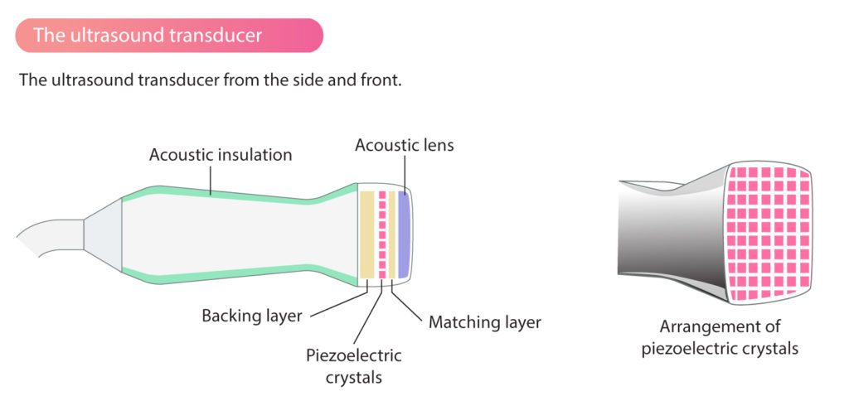

**Piezoelectric Effect**

Ultrasound transducers operate based on the piezoelectric effect. Piezoelectric crystals change shape when an electrical voltage is applied, allowing an alternating voltage to cause rapid oscillation and generate ultrasound waves. Conversely, when these crystals are vibrated by returning ultrasound waves, they produce an electrical voltage that can be detected as a signal. Thus, the crystals are responsible for both generating and detecting ultrasound.

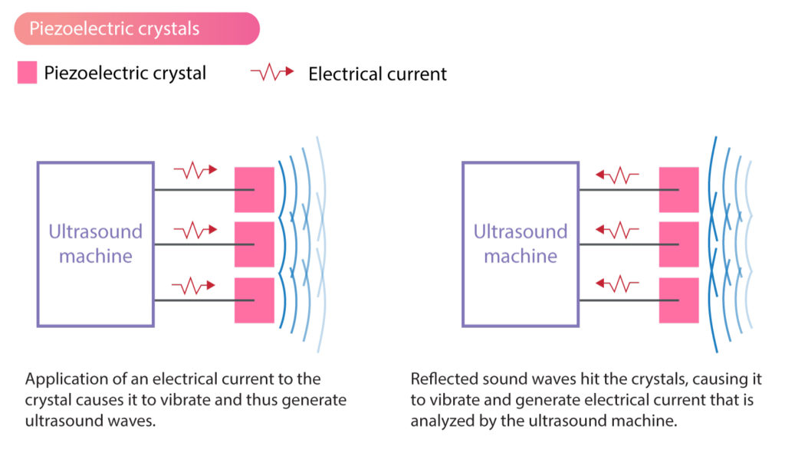

**Transmission and Reception of Ultrasound**

A transducer transmits short bursts of ultrasound lasting a few microseconds and then waits for several hundred microseconds for the reflected ultrasound to return before sending the next burst. The transducer measures the time taken for the pulse to return, known as the round-trip time. Using this time and the known propagation velocity of ultrasound in soft tissue, the echo machine calculates the distance to the reflector. The transducer also assesses the intensity of the returning signal, which is essential for constructing the image display.

**3.4 Ultrasound Beam**

**Ultrasound Beam Characteristics**

The ultrasound beam remains cylindrical for a short distance after leaving the transducer, known as the near field, before diverging into the far field. Imaging quality is optimal within the near field, and maximizing its depth is crucial for image quality.

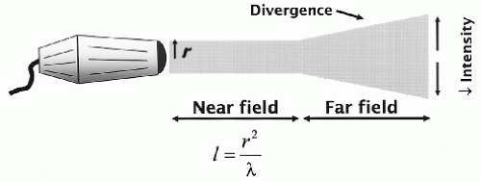

**Near Field (Fresnel Zone)**

* **Shape:** The beam is more cylindrical and tends to be relatively narrow.
* **Resolution:** High resolution in the near field, as the sound waves are still tightly focused.
* **Depth of Penetration:** The near field has limited depth penetration, which may restrict the visualization of deeper structures.

**Far Field (Fraunhofer Zone)**

* **Shape:** The beam becomes more conical, or fan shaped as it diverges.
* **Resolution:** Resolution decreases in the far field because the beam is more spread out, making it harder to focus on small structures.
* **Depth of Penetration:** The far-field provides better penetration, making it suitable for examining deeper anatomical structures.

**Optimising Near Field**

A plastic acoustic lens at the front of the transducer aids in focusing the ultrasound beam. Focusing the ultrasound beam does not change the length of the near field but results in a narrower beam and higher resolution within the near field, although it may widen the beam in the far field.

The length of the near field (l) is influenced by the transducer's radius (r) and the wavelength (λ) of the emitted ultrasound. Decreasing the wavelength (by increasing the frequency) or increasing the transducer size will both lengthen the near field. While it might seem optimal to use a large-diameter, high-frequency transducer to maximize the near field, practical limitations exist. A larger transducer may not fit between the ribs, and higher frequencies, although they increase the near field length, also cause greater attenuation and reduced penetration, limiting their effectiveness. Thus, a balance between these factors is necessary for optimal ultrasound imaging performance.

**3.5 Harmonic Imaging**

**Harmonic Generation**

Second harmonic imaging (SHI) is an advanced ultrasound technique that improves image resolution, contrast, and tissue characterization by utilizing the nonlinear properties of tissues. In conventional ultrasound, high-frequency sound waves (2-15 MHz) are sent into the body, and the returning echoes create an image. In SHI, when these waves interact with tissues, some energy is converted to a higher frequency, specifically twice the original frequency (the second harmonic), due to tissue elasticity. The signal is then filtered to remove the fundamental frequency, and the image is constructed using the second harmonic, resulting in clearer, higher-resolution images.

**Benefits of Second Harmonic Imaging**

* **Improved Resolution:** Improves lateral resolution but reduces axial resolution.
* **Reduced Artifacts**: By focusing on the second harmonic, clinicians can reduce artifacts such as side lobes and reverberation.

**Disadvantages of Second Harmonic Imaging**

* **Higher Power Output:** Requires a greater power output compared to fundamental imaging.
* **Altered Myocardial Texture:** The appearance of myocardial texture may be slightly modified.
* **Altered Valve Appearance:** Structures such as valve leaflets may appear thicker than they do in fundamental imaging, which could affect interpretation.

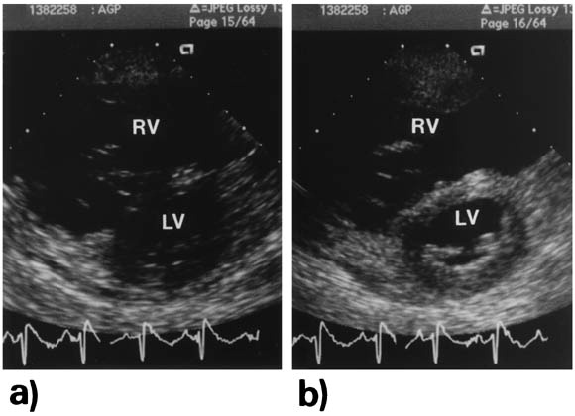

Link: <https://www.onlinejase.com/article/S0894-7317%2898%2900122-9/fulltext#figure-0010>

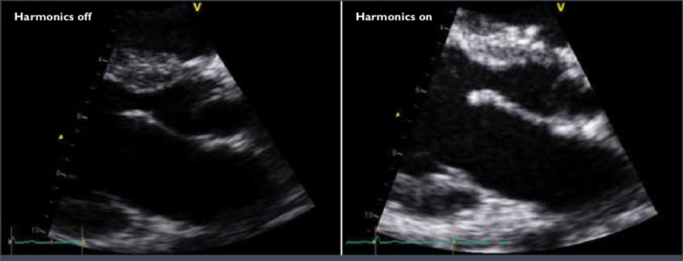

Link: <https://www.researchgate.net/figure/Harmonic-Imaging-Harmonic-imaging-improves-overall-image-quality-and-has-become-almost_fig2_321673670>

**3.6 Axial Resolution**

Axial resolution refers to the ability to distinguish objects that are aligned along the axis of the ultrasound beam. The typical axial resolution is around 3 mm, which indicates the minimum distance at which two objects can be distinguished along the beam's axis. Axial resolution can be improved by:

* **Higher Frequency Ultrasound:** Higher frequency ultrasound waves have shorter wavelengths, which improve the ability to detect small differences between closely spaced objects.
* **Shorter Pulse Length:** A shorter pulse length is associated with a longer listening period, which improves axial resolution.

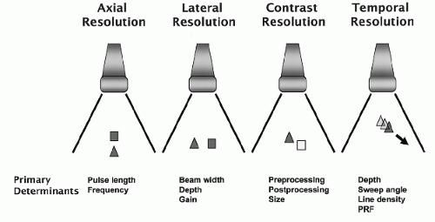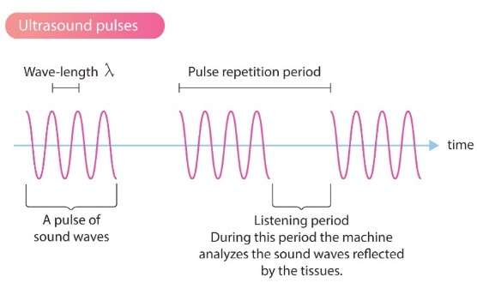

**3.7 Lateral Resolution**

Lateral resolution, also known as azimuthal resolution, pertains to the ability to differentiate objects that are positioned side by side, perpendicular to the ultrasound beam. The typical lateral resolution is around 1 mm, indicating the minimum distance at which two side-by-side objects can be distinguished. Key points include:

* **Beam Width:** A narrower beam enhances lateral resolution.
* **Focusing:** The beam can be optimized by focusing on the region of interest, improving resolution.
* **Distance from Transducer:** Lateral resolution is better at near field.
* **Tissue Harmonic Imaging (THI):** Activate THI to improve lateral resolution.
* **Gain Settings:** Higher gain settings can degrade lateral resolution.

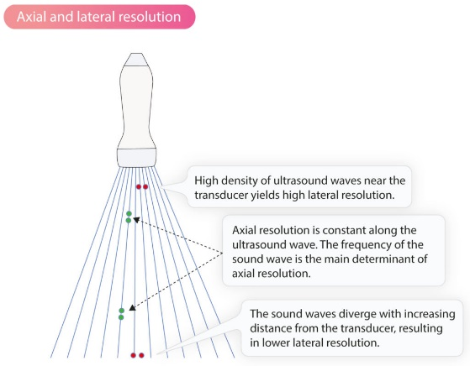

**3.8 Temporal Resolution**

Temporal resolution, or frame rate, is crucial for distinguishing events that occur in close succession. It is influenced by:

* **Sector Width:** A narrow sector width has lesser scan lines thus improving temporal resolution
* **Sector Depth:** Shallower imaging depths allow the ultrasound machine to process echoes faster because the sound waves travel shorter distances.
* **Use M-Mode:** M-mode imaging provides very high sampling rates, typically around 1800 times per second. In contrast, 2D echo imaging has a slower frame rate, usually between 20 to 30 frames per second, because it requires a larger volume of ultrasound data to create each frame.
* **Turn off Doppler Mode:** Colour Doppler and Spectral Doppler require more processing time to visualize blood flow dynamics and often result in lower frame rates compared to basic 2D imaging.

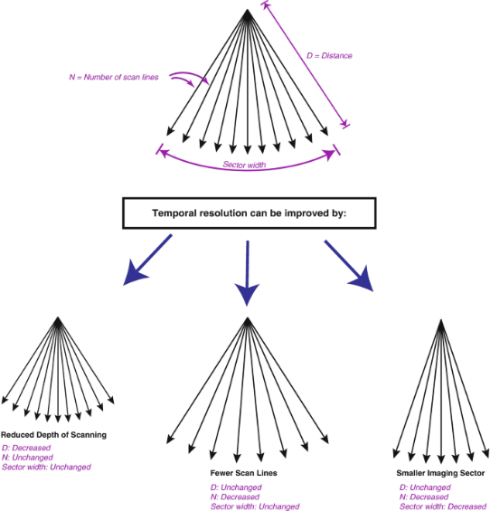

**3.9 Acoustic Shadowing**

Acoustic shadowing occurs when the ultrasound waves encounter a structure with a high impedance (resistance to the transmission of sound waves), such as prosthetic valves. These structures reflect or absorb the sound waves, preventing them from passing through and reaching deeper tissues. The lack of returning sound waves from behind the dense structure results in a shadow or absence of echoes in that region.

**Overcoming Acoustic Shadowing**

* **Adjust Angle of the Probe**: Altering the angle of the ultrasound probe can change the path of the ultrasound waves. This may help reduce or minimize the shadowing effect by avoiding the direct reflection from dense structures.
* **Use a Different Echo Window**: Sometimes, acoustic shadowing can be minimized by exploring different acoustic windows or areas of the body through which the ultrasound waves can be transmitted. For example, a subcostal or apical approach may provide a better view of heart structures if the parasternal window is obstructed by the ribs.

Link: <https://www.asecho.org/wp-content/uploads/2014/05/2009_Evaluation-of-Prosthetic-Valves.pdf>

**3.10 Reverberation Artefact**

Reverberation happens when ultrasound waves bounce multiple times between two highly reflective surfaces before returning to the transducer. This results in 'ghost' images in the far field which move in sync with the original structure. Reverberation also often appears as a series of parallel, equidistant lines on the ultrasound image.

**Overcoming Reverberation Artefact**

* **Change the Probe Angle:** Changing the angle may move the reflecting surfaces out of alignment with the beam and reduce the artifact.
* **Optimize Imaging Settings:** Reducing the gain or adjusting the dynamic range can help minimize the visibility of reverberation artifacts. Lowering the gain can reduce the intensity of false echoes, making the real tissue structures clearer.

Link: <https://www.asecho.org/wp-content/uploads/2021/01/2016_JASE_Bertrand_Fact-or-Artifact.pdf>

**3.11 Beam Width Artefact**

Beam width artifact in echocardiography occurs when the ultrasound beam is too wide for the target structure, leading to blurred edges and loss of resolution. This artifact can distort the assessment of small structures like heart valves. This can make it difficult to evaluate the function of the valve or identify abnormalities such as stenosis, regurgitation, or prolapse. By optimizing the focus at the level of the target structure, you can create a narrower beam and improve the lateral resolution, which minimizes the impact of beam width artifacts.

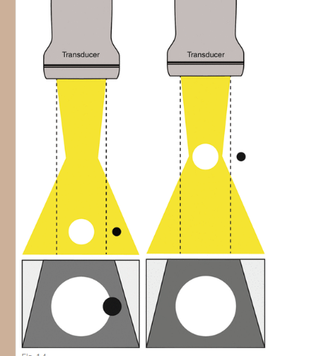

**3.12 Side Lobe Artefact**

Side lobe artefacts, also known as grating lobe artefacts, occur when secondary, weaker sound waves (side lobes) reflect off adjacent structures and are detected by the ultrasound transducer, creating false echoes or misplaced structures on the image. An example would be a false aortic dissection. Side lobe artefact can be minimised by using tissue harmonic imaging and turning down the gain.

Link: <https://www.asecho.org/wp-content/uploads/2021/01/2016_JASE_Bertrand_Fact-or-Artifact.pdf>